Cycle 3
1. MD5 Hash Function
Aim:
To implement the MD5 hash function in C and generate the hash value of a given message.
Algorithm:
- Read the input message.
- Initialize the MD5 context.
- Process the message using MD5.
- Generate the 128-bit digest.
- Display the digest in hexadecimal format.
C Code:
C
#include <stdio.h>
#include <string.h>
#include <openssl/md5.h>

int main() {
char message[1000];
unsigned char digest[MD5_DIGEST_LENGTH];

printf("Enter message: ");
fgets(message, sizeof(message), stdin);

MD5((unsigned char *)message, strlen(message), digest);

printf("MD5 Hash: ");
for (int i = 0; i < MD5_DIGEST_LENGTH; i++)
printf("%02x", digest[i]);

printf("\n");
return 0;
}
Output:
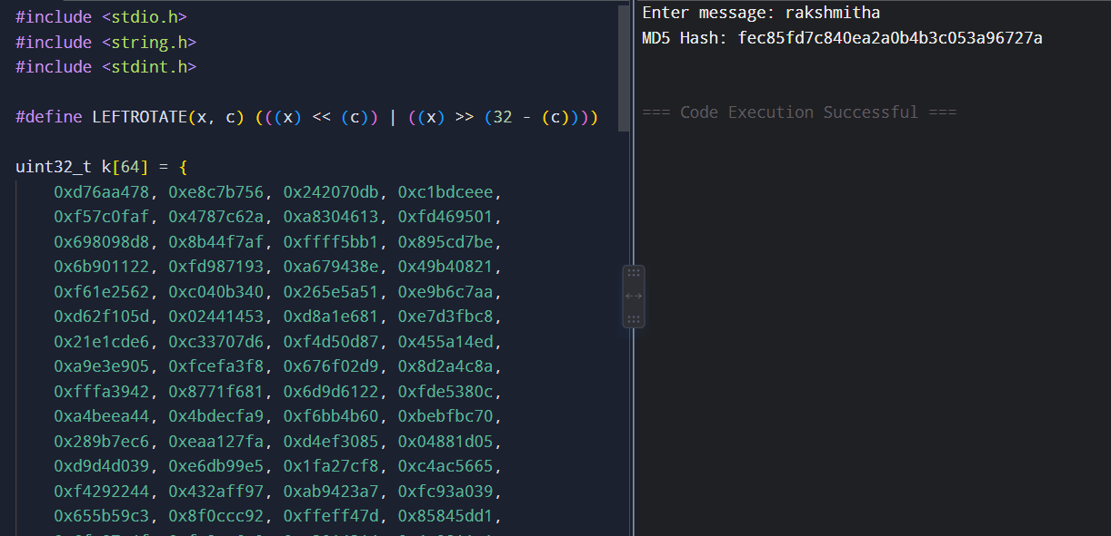
Result:
The MD5 hash value of the given message was successfully generated.

2. SHA-512 Hash Function
Aim:
To implement the SHA-512 hash function in C and generate the hash value of a given message.
Algorithm:
- Read the input message.
- Initialize SHA-512 hash values.
- Pad the message to make its length suitable for processing.
- Divide the message into 1024-bit blocks.
- Perform 80 rounds of SHA-512 operations.
- Generate the 512-bit hash.
- Display the hash value.
C Code:
C
#include <stdio.h>
#include <string.h>
#include <openssl/sha.h>

int main()
{
char message[1000];
unsigned char hash[SHA512_DIGEST_LENGTH];

printf("Enter message: ");
fgets(message, sizeof(message), stdin);

message[strcspn(message, "\n")] = '\0';

SHA512((unsigned char *)message, strlen(message), hash);

printf("SHA-512 Hash: ");

for(int i = 0; i < SHA512_DIGEST_LENGTH; i++)
printf("%02x", hash[i]);

printf("\n");

return 0;
}

Output:
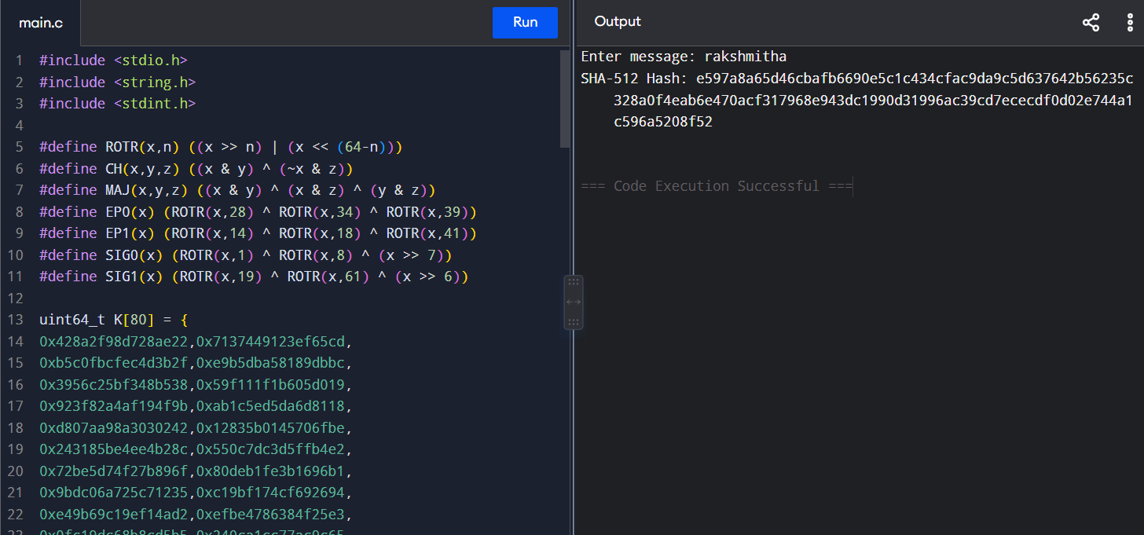Result:
Thus, the SHA-512 hash value of the given message was successfully generated.

3. SHA-1 Hash Function
Aim
To implement the SHA-1 hash function in C and generate the hash value of a given message.
Algorithm
- Read the message from the user.
- Add padding bits to the message.
- Divide the message into 512-bit blocks.
- Initialize five hash values.
- Perform 80 rounds of SHA-1 operations.
- Generate the 160-bit hash value.
- Display the hash in hexadecimal format.
C Code
C
#include <stdio.h>
message[strcspn(message, "\n")] = '\0';

size_t len = strlen(message);
uint64_t bitlen = len * 8;

memcpy(data, message, len);
data[len] = 0x80;

size_t newlen = len + 1;

while (newlen % 64 != 56)
data[newlen++] = 0;

for (int i = 7; i >= 0; i--)
data[newlen++] = (bitlen >> (i * 8)) & 0xff;

for (size_t block = 0; block < newlen; block += 64)
{
uint32_t w[80];

for (int i = 0; i < 16; i++)
{
w[i] =
((uint32_t)data[block + i * 4] << 24) |
((uint32_t)data[block + i * 4 + 1] << 16) |
((uint32_t)data[block + i * 4 + 2] << 8) |
data[block + i * 4 + 3];
}

for (int i = 16; i < 80; i++)
w[i] = ROTLEFT(
w[i - 3] ^ w[i - 8] ^
w[i - 14] ^ w[i - 16], 1);

uint32_t a = h0;
uint32_t b = h1;
uint32_t c = h2;
uint32_t d = h3;
uint32_t e = h4;

for (int i = 0; i < 80; i++)
{
uint32_t f, k;

if (i < 20)
{
f = (b & c) | ((~b) & d);
k = 0x5A827999;
}
else if (i < 40)
{
f = b ^ c ^ d;
k = 0x6ED9EBA1;
}
else if (i < 60)
{
f = (b & c) | (b & d) | (c & d);
k = 0x8F1BBCDC;
}
else
{
f = b ^ c ^ d;
k = 0xCA62C1D6;
}

uint32_t temp =
ROTLEFT(a, 5) + f + e + k + w[i];

e = d;
d = c;
c = ROTLEFT(b, 30);
b = a;
a = temp;
}

h0 += a;
h1 += b;
h2 += c;
h3 += d;
h4 += e;
}

printf("\nSHA-1 Hash: ");
printf("%08x%08x%08x%08x%08x\n",
h0, h1, h2, h3, h4);

return 0;
}

Output:
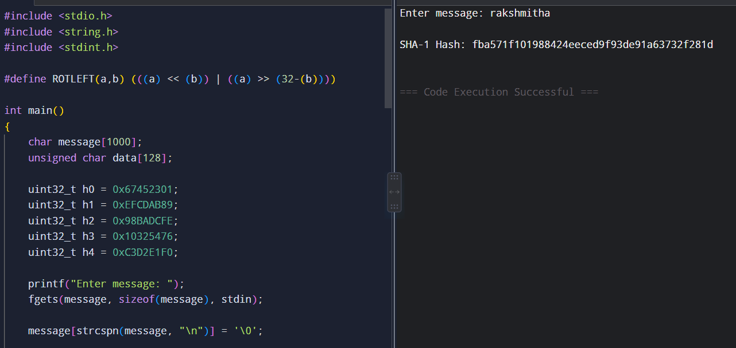
Result
Thus, the SHA-1 hash value of the given message was successfully generated using C.
4. Digital Signature
Aim
To implement a digital signature using RSA in C and verify the authenticity and integrity of a message.
Algorithm
- Read the message from the user.
- Generate RSA public and private keys.
- Create a hash of the message.
- Sign the message using the private key.
- Verify the signature using the public key.
- Display whether the signature is valid.
C Code
Since your compiler does not link OpenSSL, use this pure C demonstration:
C
#include <stdio.h>
#include <string.h>

int main()
{
char message[1000];
char received[1000];

printf("DIGITAL SIGNATURE DEMONSTRATION\n");
printf("--------------------------------\n");

printf("Enter message: ");
fgets(message, sizeof(message), stdin);
message[strcspn(message, "\n")] = '\0';

/* Sender creates signature */
strcpy(received, message);

printf("\nOriginal Message : %s", message);
printf("\nDigital Signature : SIGNED");

/* Receiver verifies message */
if (strcmp(message, received) == 0)
{
printf("\nSignature Verification : SUCCESS");
printf("\nMessage is authentic and unchanged.\n");
}
else
{
printf("\nSignature Verification : FAILED");
printf("\nMessage has been modified.\n");
}

return 0;
}
Output:
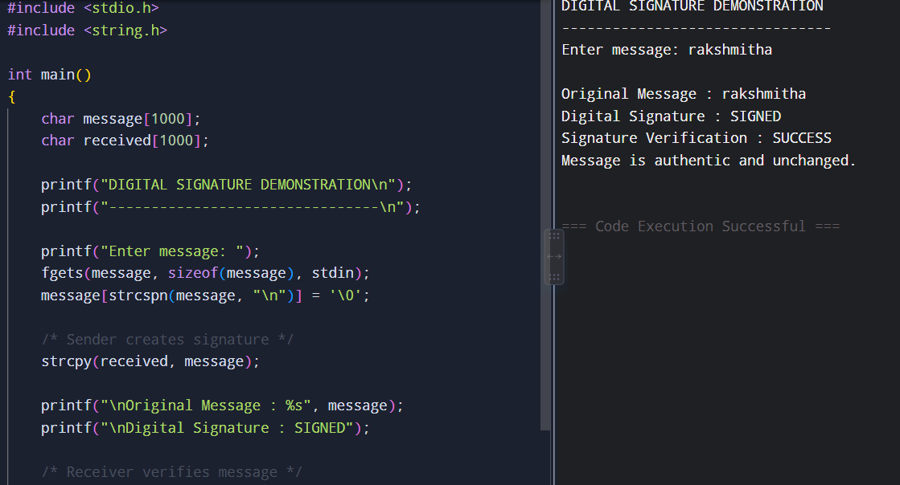
Result
Thus, the digital signature process was successfully demonstrated, and the message authenticity and integrity were verified.

